Midwives’ Acceptance of an Internet of Things-Enabled Maternal Health Website After Guided Training: A Pre-Post Study
Abstract
Background and Aim: Digital maternal health systems depend on whether frontline providers consider them useful, understandable, and compatible with routine practice. This study assessed changes in midwives’ acceptance of an Internet of Things maternal health monitoring website after guided training. Methods and Materials: A one-group pretest-posttest study involved 30 practising midwives in Sleman Regency, Indonesia. Participants received orientation, demonstration, supervised hands-on practice, and repeated use of simulated maternal cases over one month. Acceptance was measured with a 27-item questionnaire covering six domains. Paired differences were analysed using the Wilcoxon signed-rank test. Results: Mean total scores increased from 110.23 ± 3.00 to 125.77 ± 2.99. The mean change was 15.53 points (95% confidence interval: 14.19-16.88), and all participants had higher posttest scores. The Wilcoxon test showed a significant increase (W = 0, p < 0.001). The mean normalised gain was 0.63. Cronbach’s alpha was 0.584 at pretest and 0.647 at posttest. Conclusion: Guided training was associated with more favourable website acceptance. The uncontrolled design and preliminary psychometric properties limit causal interpretation; larger controlled studies should assess sustained use, objective competence, usability, and effects on clinical workflow.
Keywords: Midwifery; Digital Health; Internet of Things; Attitude of Health Personnel; Telemedicine
Introduction
Maternal mortality remains a major public health concern in Indonesia, and timely antenatal monitoring, complete documentation, and access to skilled care remain central to prevention efforts (1). Digital technologies can extend maternal monitoring beyond face-to-face encounters by supporting remote review of physiological and clinical information (2-6).
Successful implementation depends on human and organisational conditions as well as technical performance. Health personnel readiness, digital literacy, information quality, ease of use, interoperability, infrastructure, data security, and compatibility with established workflows can influence adoption and continued use (7-9). A technically functional platform may still fail when users do not understand the information presented or cannot integrate digital tasks into routine practice.
Technology acceptance offers a useful framework for early implementation evaluation. The Technology Acceptance Model proposes that perceived usefulness and perceived ease of use influence attitudes and behavioural intention (10). The DeLone and McLean information systems success model similarly highlights information quality, system quality, service quality, use, satisfaction, and net benefits (11). These constructs are relevant when a new maternal health platform is introduced to midwives, who are expected to interpret information, document care, identify risks, plan management, and support referral.
Previous studies of telemedicine and mobile health in pregnancy have found generally favourable attitudes among health professionals, alongside concerns about reliability, workload, professional responsibility, confidence, and fit with existing services (12-15). Guided training may reduce uncertainty by allowing intended users to practise navigation, data entry, interpretation, and response before routine implementation. Digital health education increasingly emphasises active engagement with applications and repeated task performance rather than passive instruction alone (16,17).
A multidisciplinary consortium developed a prototype maternal health monitoring website linked conceptually to an Internet of Things workflow. Before wider implementation, the website and a user-acceptance questionnaire underwent expert review. Evidence was still needed on how practising midwives perceived the platform after structured exposure. Therefore, this study aimed to compare total acceptance scores before and after guided training and repeated scenario-based use. Secondary objectives were to describe changes in information quality, system quality, service quality, perceived usefulness, perceived ease of use, and acceptance, and to report preliminary internal consistency estimates for the questionnaire.
Methods
Study Design and Setting
This exploratory one-group pretest-posttest study was embedded in a broader action-research project involving prototype development, expert review, user exposure, observation, and iterative refinement. The field evaluation was conducted in Sleman Regency, Indonesia, in 2024. The design was intended to provide preliminary evidence about changes in users’ perceptions during early implementation; it was not designed to establish clinical effectiveness or compare the website with another educational or technological intervention.
The broader action-research process included planning, action, observation, and reflection. Planning involved preparing the website, a dummy wearable workflow, simulated cases, a user guide, and a questionnaire. Action consisted of guided training and repeated use by midwives. Observation included expert feedback and paired questionnaire responses. Reflection involved multidisciplinary review of the findings to identify priorities for interface, questionnaire, and implementation refinement. The manuscript reports the user-acceptance component of this cycle.
Participants
A pragmatic volunteer sample of 30 practising midwives was recruited through invitations to participate in the field evaluation. Eligible participants were practising midwives who were willing to attend the guided training, use the prototype website during the evaluation period, provide written informed consent, and complete both questionnaire administrations. Participants without complete paired data were to be excluded from the paired analysis. All enrolled participants completed both assessments.
The available study documentation did not include a formal sample-size calculation. The sample was therefore treated as an exploratory implementation cohort rather than a confirmatory effectiveness sample. Age, highest educational qualification, and length of professional experience were collected for descriptive purposes. Inferential subgroup analyses were not undertaken because several categories contained few participants and no subgroup hypotheses had been prespecified.
Digital System and Guided Training
The project developed a custom web-based application intended to connect maternal health records with information generated by an Internet of Things prototype. No commercial manufacturer was involved. The website included sections for patient identity, subjective history, objective maternal health data, automatically displayed risk-related information, professional analysis, and a management-plan field. The conceptual workflow linked a dummy wearable device, a secure database or cloud layer, and mobile or desktop access for health professionals.
During this preliminary evaluation, participants worked with simulated or manually entered maternal data rather than verified real-time clinical measurements. The website functioned as an educational and implementation prototype, not as a replacement for established antenatal records or professional judgement. Sensor accuracy, diagnostic validity, cybersecurity performance, data-transfer reliability, clinical decisions, and maternal or neonatal outcomes were not evaluated.
A multidisciplinary team with expertise in midwifery, nursing, communication, and digital technology facilitated the intervention. Training included an introduction to the purpose and workflow of the system, demonstration of website functions, and supervised hands-on use through mobile or desktop devices. Participants practised locating patient and visit information, entering or reviewing subjective and objective data, examining risk-related displays, and completing professional analysis and management-plan fields.
After orientation and demonstration, participants entered a one-month guided-use period. Simulated maternal cases were made available every two days, providing repeated opportunities to navigate the website and relate displayed information to expected midwifery tasks. The available implementation records confirmed the sequence and one-month case schedule but did not document the exact duration of each training session. The intervention should therefore be interpreted as structured orientation, demonstration, practice, and repeated case use rather than a precisely time-standardised educational dose.
Questionnaire Development and Outcome Measures
Website acceptance was initially assessed with a 29-item questionnaire. Three experts—a professor of information technology, a doctoral-level industrial technology specialist, and a doctoral-level midwifery specialist—reviewed the website and questionnaire. Their qualitative review considered comprehensibility, relevance, ambiguity, sentence structure, organisation of information, separation of stable patient data from visit-specific data, suitability of language, and presentation of icons and patient information. Two service-quality items were removed after review, resulting in a 27-item questionnaire.
The expert process was a qualitative content and usability review rather than formal psychometric validation. The available records did not contain item-level content-validity indices or a quantitative threshold for item retention. The final questionnaire comprised information quality (7 items), system quality (6 items), service quality (3 items), perceived usefulness (3 items), perceived ease of use (5 items), and acceptance (3 items). Each item was scored from 1 to 5, with higher scores indicating a more favourable evaluation. Total possible scores ranged from 27 to 135. The primary outcome was change in the total score; domain changes and internal consistency were secondary descriptive outcomes.
Data Collection
The pretest was administered before the one-month guided-use period, and the posttest was administered after repeated case-based exposure. The same 27 items and scoring direction were used at both time points. Numeric study codes were used to match paired responses without including names or contact details. The analytical dataset contained complete item-level and total responses for all 30 participants.
Statistical Analysis
Participant characteristics were summarised using frequencies and percentages. Total and domain scores were summarised using means and standard deviations; medians and interquartile ranges were also calculated for total scores. Cronbach’s alpha was estimated separately at pretest and posttest and interpreted cautiously because the questionnaire included six related but distinct domains and the sample was small.
A paired difference score was calculated as posttest minus pretest. Normality of the differences was examined using the Shapiro-Wilk test and visual review. Because the distribution was non-normal, the Wilcoxon signed-rank test was the primary inferential analysis. The mean change and 95% confidence interval, Cohen’s dz, and individual normalised gain, calculated as (posttest - pretest)/(135 - pretest), were reported descriptively. Domain scores were not subjected to multiple significance tests. Tests were two-sided, with p < 0.05 considered statistically significant. Analyses for this manuscript were performed in Python 3.13 using NumPy 2.3.5 and SciPy 1.17.0.
Ethical Considerations
The study was conducted in accordance with the Declaration of Helsinki and was approved by the responsible institutional research ethics committee (No. 3983/KEP-UNISA/IX/2024). Participation was voluntary, and written informed consent was obtained before data collection. Participants were informed that participation would not affect their professional standing. Results were reported in aggregate, and the analytical dataset contained no direct personal identifiers.
Results
Participant Characteristics
All 30 midwives completed both assessments. The largest age group was 41-50 years (13/30, 43.3%). Sixteen participants (53.3%) held a bachelor’s degree or Diploma 4 qualification, and 25 (83.3%) had more than 10 years of professional experience (Table 1).
Internal Consistency
Cronbach’s alpha was 0.584 at pretest and 0.647 at posttest, indicating modest internal consistency. The questionnaire was therefore treated as a preliminary multidimensional measure rather than an established scale.
Changes in Website Acceptance
The mean total score increased from 110.23 ± 3.00 at pretest to 125.77 ± 2.99 at posttest. The corresponding medians were 110.0 (interquartile range: 108.0-111.75) and 125.0 (interquartile range: 124.0-126.75). All 30 participants recorded higher posttest scores (Figure 2).
The mean increase was 15.53 ± 3.61 points (95% confidence interval: 14.19-16.88). Paired differences were non-normally distributed (Shapiro-Wilk p = 0.024), and the Wilcoxon signed-rank test showed a significant increase (W = 0, p < 0.001). Cohen’s dz was 4.31, and the mean normalised gain was 0.63. These magnitude estimates describe change within the cohort and do not compensate for the absence of a comparison group.
Scores increased across all six domains (Table 2). The largest absolute mean changes occurred for information quality (4.43 points), system quality (3.57 points), and perceived ease of use (3.10 points). Because the domains contained different numbers of items, raw changes are not directly comparable. On a per-item basis, the largest increase occurred in acceptance (0.80 points per item), followed by information quality (0.63), perceived ease of use (0.62), and system quality (0.60).
Discussion
Principal Findings
Midwives evaluated the Internet of Things maternal health website more favourably after guided training and one month of repeated case-based use. Every participant had a higher posttest score, and improvements occurred across all six domains. The findings suggest that acceptance measured before adequate exposure may underestimate how intended users perceive a system after they have navigated it, examined the information presented, and practised tasks that resemble routine work.
The change cannot be attributed solely to the website or training because there was no comparison group. Demonstration, repeated practice, facilitator attention, repeated questionnaire exposure, and enthusiasm about participating in an innovation project may all have contributed. High baseline and posttest scores also indicate a possible ceiling effect and social-desirability influence. The study therefore provides developmental implementation evidence rather than definitive proof of effectiveness.
Interpretation and Comparison With Previous Research
The increases in perceived usefulness and ease of use are consistent with the Technology Acceptance Model, which proposes that these beliefs shape attitudes and intention to use technology (10). Demonstration and repeated practice may have replaced anticipated difficulty with direct experience. Participants could judge the system based on their ability to locate data and complete tasks rather than on assumptions about an unfamiliar platform.
The six questionnaire domains also reflect the DeLone and McLean information systems success model (11). Information quality, system quality, and service quality can influence use, satisfaction, and perceived benefits. Improvements in these domains may indicate that participants became better able to understand the content and navigation logic after repeated exposure. They may also reflect the value of expert-led refinement before field use.
The results align with evidence that health professionals’ readiness for digital systems is influenced by usefulness, usability, confidence, infrastructure, interoperability, and fit with established work processes (7-9). Studies of telehealth and mobile health in pregnancy have similarly described potential benefits for monitoring and communication alongside concerns about reliability, workload, responsibility, and the quality of remotely generated information (12-15). The present study adds a practice-oriented training perspective by showing that perceptions changed after structured exposure.
Digital health education literature increasingly supports active engagement with applications rather than conceptual teaching alone (16,17). The intervention combined explanation, demonstration, supervised practice, and repeated scenario use. Although it was not compared with lecture-only or self-directed instruction, the consistent upward pattern supports further testing of structured onboarding as part of implementation.
Implications for Nursing and Midwifery Practice
Digital-system implementation should be treated as a practice change, not simply a software installation. Midwives need opportunities to navigate the platform, recognise where information is stored, practise complete data entry, interpret risk-related displays, and connect digital outputs with communication, documentation, escalation, and referral responsibilities. A brief demonstration or written manual alone may not be sufficient.
Scenario-based practice is particularly relevant in maternal care because information is interpreted within a clinical context. Simulated cases allow facilitators to vary histories and findings, identify misunderstandings, and discuss how the website should support rather than replace professional judgement. Repeated use can also reveal wording or navigation features that remain unclear after initial orientation.
Acceptance is necessary but not equivalent to competence. A user may consider a website useful and easy to use without demonstrating accurate data entry, correct interpretation, or safe action. Nursing and midwifery managers should therefore pair acceptance measures with objective indicators such as task completion, documentation accuracy, error frequency, time to complete a case, recognition of abnormal information, appropriate follow-up, and need for technical support.
Positive perceptions will improve services only if the platform produces complete, accurate, timely, secure, and interoperable information. Human-factors and health information systems research emphasises readable wording, predictable navigation, appropriate information density, and alignment with user tasks (18-22). Digital maternal and child health records may support continuity, but their value depends on governance, connectivity, technical support, and a functioning response pathway (23-26). The present study did not measure these service outcomes.
Instrument Considerations
The questionnaire covered relevant concepts and was reviewed by technology and midwifery experts, but qualitative expert review is not equivalent to formal validation. Item-level content-validity indices were unavailable, and overall Cronbach’s alpha remained modest. The instrument combined six domains, several domains contained only three items, and responses showed limited dispersion; these factors can reduce alpha. Larger studies should examine item performance, domain-specific reliability, factor structure, convergent validity, and test-retest stability.
Strengths and Limitations
Strengths included complete paired follow-up, item-level data, reporting of descriptive and inferential results, inclusion of multiple acceptance domains, and transparent reporting of non-normal differences and modest reliability. Multidisciplinary expert feedback was incorporated into the website and questionnaire before field use.
The main limitation was the uncontrolled one-group design. The volunteer sample was small and drawn from one geographical area, and no formal sample-size calculation was available. Exact session duration and training-fidelity measures were not documented. The questionnaire requires further validation, and domain changes were descriptive. The study did not assess objective competence, standardised usability, sustained routine use, workload, technical performance, data security, clinical decisions, or maternal and neonatal outcomes.
Future Research
Future studies should use larger multisite samples and a comparison condition such as usual orientation, self-directed instruction, a wait-list, or stepped-wedge implementation. Prespecified sample-size calculations and follow-up after facilitator support has ended would strengthen inference. Acceptance should be assessed alongside task performance, data quality, system reliability, workflow integration, referral decisions, and user-support requirements. Including pregnant women, managers, information-technology staff, and other health professionals would provide a more complete assessment of readiness for scale-up.
Conclusion
Guided training and repeated scenario-based use were associated with higher acceptance of an Internet of Things maternal health website among 30 midwives. The findings support structured onboarding during early digital health implementation. However, the uncontrolled design, high baseline scores, and preliminary instrument properties prevent causal conclusions. Controlled studies should determine whether favourable acceptance is sustained and translates into competent use, reliable data, effective workflow integration, and improved maternal health services.
Acknowledgment
The authors thank the participating midwives and the technology and midwifery experts who reviewed the website and questionnaire.
Funding
This study received competitive governmental research funding. Full funding details are provided on the separate title page.
Conflict of Interest
The authors declare no conflict of interest.
Data Availability
The anonymised participant-level data are available from the corresponding author on reasonable request, subject to ethical and institutional approval.
References
1. Syairaji M, Nurdiati DS, Wiratama BS, Prüst ZD, Bloemenkamp KWM, Verschueren KJC. Trends and causes of maternal mortality in Indonesia: a systematic review. BMC Pregnancy Childbirth. 2024;24:515. https://doi.org/10.1186/s12884-024-06687-6
2. Liu L, Pu Y, Fan J, Yan Y, Liu W, Luo K, et al. Wearable sensors, data processing, and artificial intelligence in pregnancy monitoring: a review. Sensors (Basel). 2024;24(19):6426. https://doi.org/10.3390/s24196426
3. Alim A, Imtiaz MH. Wearable sensors for the monitoring of maternal health: a systematic review. Sensors (Basel). 2023;23(5):2411. https://doi.org/10.3390/s23052411
4. Atkinson J, Hastie R, Walker S, Lindquist A, Tong S. Telehealth in antenatal care: recent insights and advances. BMC Med. 2023;21:332. https://doi.org/10.1186/s12916-023-03042-y
5. Kusyanti T, Wirakusumah FF, Rinawan FR, Muhith A, Purbasari A, Mawardi F, et al. Technology-based (mHealth) and standard/traditional maternal care for pregnant woman: a systematic literature review. Healthcare (Basel). 2022;10(7):1287. https://doi.org/10.3390/healthcare10071287
6. Sarhaddi F, Azimi I, Labbaf S, Niela-Vilén H, Dutt N, Axelin A, et al. Long-term IoT-based maternal monitoring: system design and evaluation. Sensors (Basel). 2021;21(7):2281. https://doi.org/10.3390/s21072281
7. Ngusie HS, Kassie SY, Chereka AA, Enyew EB. Healthcare providers’ readiness for electronic health record adoption: a cross-sectional study during pre-implementation phase. BMC Health Serv Res. 2022;22:282. https://doi.org/10.1186/s12913-022-07688-x
8. Canali S, Schiaffonati V, Aliverti A. Challenges and recommendations for wearable devices in digital health: data quality, interoperability, health equity, fairness. PLOS Digit Health. 2022;1(10):e0000104. https://doi.org/10.1371/journal.pdig.0000104
9. Borges do Nascimento IJ, Abdulazeem H, Vasanthan LT, Martinez EZ, Zucoloto ML, Østengaard L, et al. Barriers and facilitators to utilizing digital health technologies by healthcare professionals. NPJ Digit Med. 2023;6:161. https://doi.org/10.1038/s41746-023-00899-4
10. Davis FD. Perceived usefulness, perceived ease of use, and user acceptance of information technology. MIS Q. 1989;13(3):319–40. https://doi.org/10.2307/249008
11. DeLone WH, McLean ER. The DeLone and McLean model of information systems success: a ten-year update. J Manag Inf Syst. 2003;19(4):9–30. https://doi.org/10.1080/07421222.2003.11045748
12. Grassl N, Nees J, Schramm K, Spratte J, Sohn C, Schott TC, et al. A web-based survey assessing the attitudes of health care professionals in Germany toward the use of telemedicine in pregnancy monitoring: cross-sectional study. JMIR Mhealth Uhealth. 2018;6(8):e10063. https://doi.org/10.2196/10063
13. Widyawati MN, Astuti EHP, Kurnianingsih. Human-in-the-loop application design for early detection of pregnancy danger signs. Belitung Nurs J. 2022;8(2):161–8. https://doi.org/10.33546/bnj.1984
14. Vickery M, van Teijlingen E, Hundley V, Smith GB, Way S, Westwood G. Midwives’ views towards women using mHealth and eHealth to self-monitor their pregnancy: a systematic review of the literature. Eur J Midwifery. 2020;4:36. https://doi.org/10.18332/ejm/126625
15. Nazari M, Moayed Rezaie S, Yaseri F, Sadr H, Nazari E. Design and analysis of a telemonitoring system for high-risk pregnant women in need of special care or attention. BMC Pregnancy Childbirth. 2024;24:817. https://doi.org/10.1186/s12884-024-07019-4
16. Kleib M, Arnaert A, Nagle LM, Ali S, Idrees S, da Costa D, et al. Digital health education and training for undergraduate and graduate nursing students: scoping review. JMIR Nurs. 2024;7:e58170. https://doi.org/10.2196/58170
17. Wang B, Shi X, Han X, Xiao G. The digital transformation of nursing practice: an analysis of advanced IoT technologies and smart nursing systems. Front Med (Lausanne). 2024;11:1471527. https://doi.org/10.3389/fmed.2024.1471527
18. Sibanda K, Ndayizigamiye P, Twinomurinzi H. Industry 4.0 technologies in maternal healthcare: a bibliometric analysis and research agenda. JMIR Pediatr Parent. 2024;7:e47848. https://doi.org/10.2196/47848
19. Tieman J, Nicholls S. Enhancing the efficacy of healthcare information websites: a case for the development of a best practice framework. BMJ Open. 2024;14(9):e088789. https://doi.org/10.1136/bmjopen-2024-088789
20. Saad M, Zia A, Raza M, Kundi M, Haleem M. A comprehensive analysis of healthcare websites usability features, testing techniques and issues. IEEE Access. 2022;10:97701–18. https://doi.org/10.1109/ACCESS.2022.3193378
21. Patel VL, Kannampallil TG. Human factors and health information technology: current challenges and future directions. Yearb Med Inform. 2014;9:58–66. https://doi.org/10.15265/IY-2014-0005
22. Eslami Andargoli A, Scheepers H, Rajendran D, Sohal A. Health information systems evaluation frameworks: a systematic review. Int J Med Inform. 2017;97:195–209. https://doi.org/10.1016/j.ijmedinf.2016.10.008
23. Geldof M, Gerlach N, Portela A. Digitalization of home-based records for maternal, newborn, and child health: a scoping review. BMC Digit Health. 2023;1:32. https://doi.org/10.1186/s44247-023-00032-1
24. Worku AG, Midekssa WD, Tilahun HA, Belay HT, Abebaw Z, Mohammedsanni A, et al. The impact of health information system interventions on maternal and child health service utilizations in Ethiopia: a quasi-experimental study. Glob Health Sci Pract. 2024;12(6):e2400145. https://doi.org/10.9745/GHSP-D-24-00145
25. Faulkenberry JG, Luberti A, Craig S. Electronic health records, mobile health, and the challenge of improving global health. Curr Probl Pediatr Adolesc Health Care. 2022;52(1):101111. https://doi.org/10.1016/j.cppeds.2021.101111
26. Till S, Mkhize M, Farao J, Shandu LD, Muthelo L, Coleman TL, et al. Digital health technologies for maternal and child health in Africa and other low- and middle-income countries: cross-disciplinary scoping review with stakeholder consultation. J Med Internet Res. 2023;25:e42161. https://doi.org/10.2196/42161

Table 1. Demographic and professional characteristics of participants (n = 30)
Characteristic | n | %
Age
20-30 years | 4 | 13.3
31-40 years | 6 | 20.0
41-50 years | 13 | 43.3
51-60 years | 7 | 23.3
Highest educational qualification
Diploma 3 | 13 | 43.3
Bachelor/Diploma 4 | 16 | 53.3
Master’s degree | 1 | 3.3
Professional experience
1-5 years | 3 | 10.0
6-10 years | 2 | 6.7
More than 10 years | 25 | 83.3
Note: Percentages were calculated from n = 30. The percentage for the 20-30-year age category was recalculated from the reported frequency.

Table 2. Pretest and posttest questionnaire scores by domain
Domain | Items | Possible score | Pretest, mean ± SD | Posttest, mean ± SD | Mean change
Information quality | 7 | 7-35 | 28.37 ± 1.10 | 32.80 ± 1.19 | 4.43
System quality | 6 | 6-30 | 23.33 ± 0.92 | 26.90 ± 1.06 | 3.57
Service quality | 3 | 3-15 | 13.17 ± 0.59 | 14.20 ± 0.48 | 1.03
Perceived usefulness | 3 | 3-15 | 12.90 ± 0.31 | 13.90 ± 0.55 | 1.00
Perceived ease of use | 5 | 5-25 | 20.03 ± 1.47 | 23.13 ± 0.86 | 3.10
Acceptance | 3 | 3-15 | 12.43 ± 0.50 | 14.83 ± 0.46 | 2.40
Note: SD = standard deviation. Total-score results and the primary paired analysis are reported in the text and Figure 2.

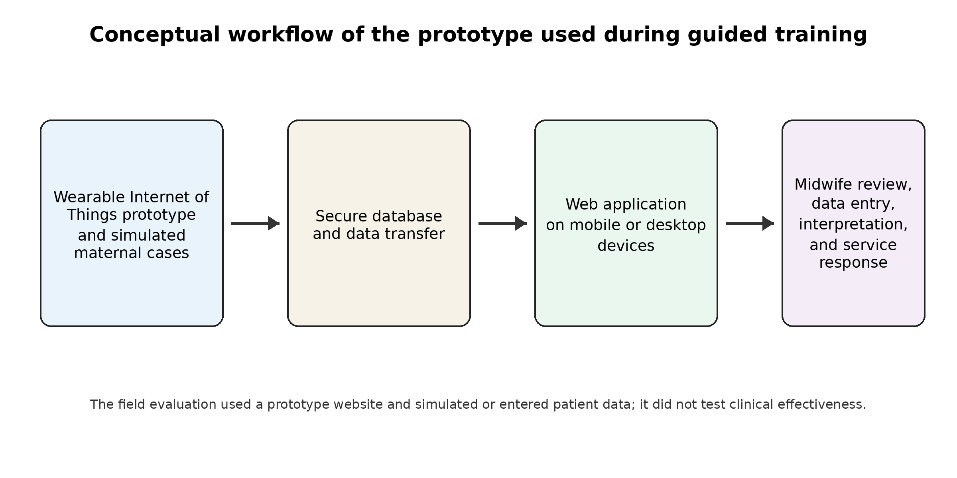
Figure 1. Conceptual workflow of the prototype used during guided training. Participants used a dummy wearable workflow, a website, and simulated or manually entered maternal data; clinical effectiveness was not tested.

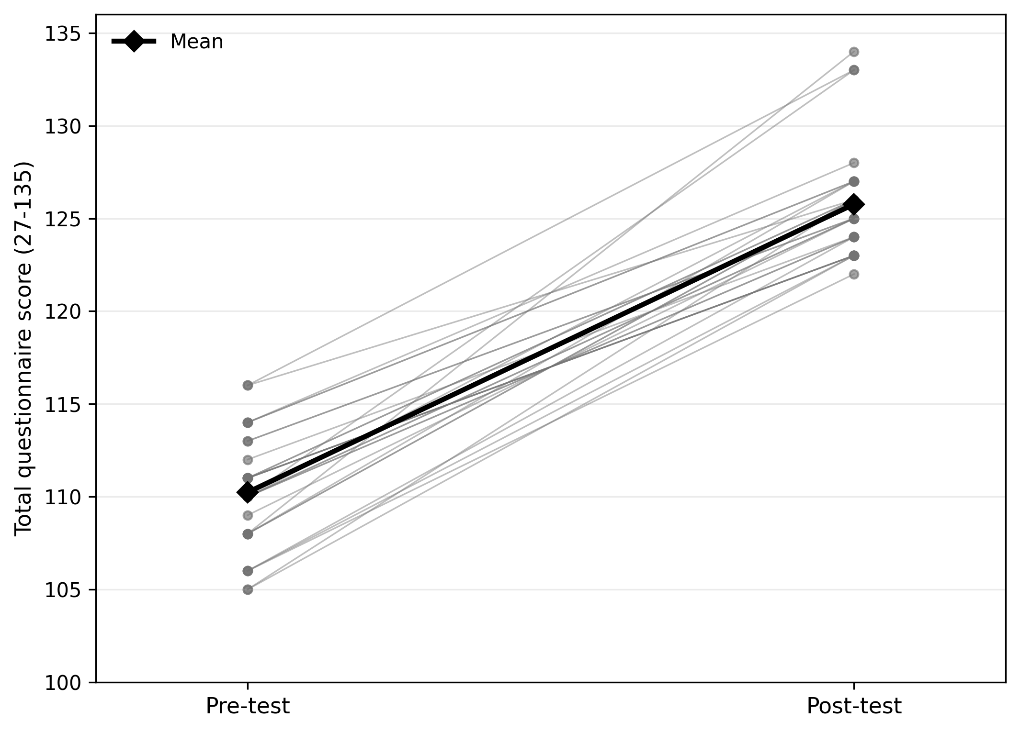
Figure 2. Paired pretest and posttest total questionnaire scores for 30 midwives. Thin lines represent individual participants, and black diamonds represent group means.

